**HMBank Database Design**

J208 Monish Coumar S

1. **Database Schema**

The database consists of three main tables:

**Customers Table**

Stores customer details.

|  |  |  |
| --- | --- | --- |
| Column Name | Data Type | Constraints |
| customer_id | INT | PRIMARY KEY, AUTO_INCREMENT |
| first_name | VARCHAR(50) | NOT NULL |
| last_name | VARCHAR(50) | NOT NULL |
| DOB | DATE | NOT NULL |
| email | VARCHAR(100) | UNIQUE, NOT NULL |
| phone_number | VARCHAR(15) | UNIQUE, NOT NULL |
| address | TEXT | NOT NULL |

**Accounts Table**

Stores account details linked to customers.

|  |  |  |
| --- | --- | --- |
| Column Name | Data Type | Constraints |
| account_id | INT | PRIMARY KEY, AUTO_INCREMENT |
| customer_id | INT | FOREIGN KEY REFERENCES Customers(customer_id) ON DELETE CASCADE |
| account_type | ENUM | ('savings', 'current', 'zero_balance') NOT NULL |
| balance | DECIMAL(15,2) | DEFAULT 0.00 |

**Transactions Table**

Stores transaction details.

|  |  |  |
| --- | --- | --- |
| Column Name | Data Type | Constraints |
| transaction_id | INT | PRIMARY KEY, AUTO_INCREMENT |
| account_id | INT | FOREIGN KEY REFERENCES Accounts(account_id) ON DELETE CASCADE |
| transaction_type | ENUM | ('deposit', 'withdrawal', 'transfer') NOT NULL |
| amount | DECIMAL(15,2) | NOT NULL CHECK (amount > 0) |
| transaction_date | TIMESTAMP | DEFAULT CURRENT_TIMESTAMP |

1. **Entity Relationship Diagram (ERD)**

The ERD represents the relationships between tables:

**One-to-Many** between Customers and Accounts

**One-to-Many** between Accounts and Transactions

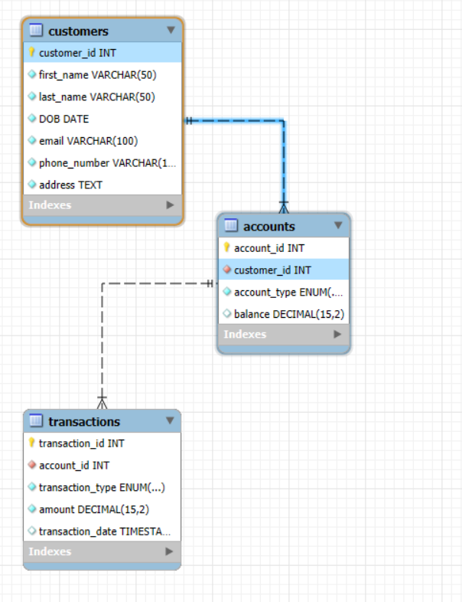

1. **Referral Integrity Constraints**

**Primary Keys:**

* + customer_id in Customers
  + account_id in Accounts
  + transaction_id in Transactions

**Foreign Keys:**

* + customer_id in Accounts references Customers(customer_id)
  + account_id in Transactions references Accounts(account_id)